DA5401: Assignment 2 MM21B051

Task 1

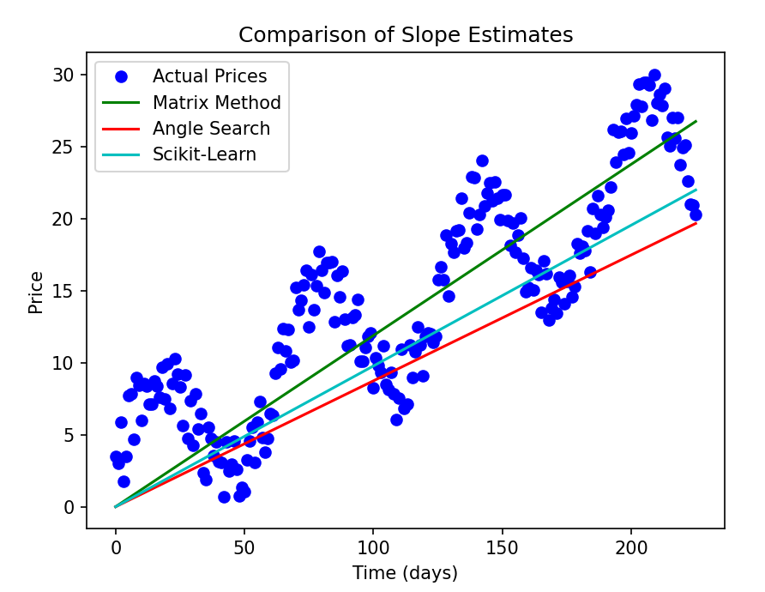

All three methods come up with similar slope values, roughly 0.1. The first method uses some math with matrices to get the slope, while the second method tries out different possibilities, and it could be made even more accurate by testing more points and making smaller adjustments. The third method just uses a common Linear Regression tool to find the slope, and it gets the same result.

Task 2

The suggested mathematical model is **y = m_1 *x + m_2 * sin(wx),** where (w) represents the frequency of the sine wave. The parameters (m_1) and (m_2) can be estimated using linear regression. To find the best frequency (w), you need to test different values and identify which one fits the data best. After analyzing the coefficients, it turns out that (f_2 ) has the strongest influence among the frequencies tested, so the model simplifies to ( y = m_1 *x + m_2 *sin(0.1 *x) ).

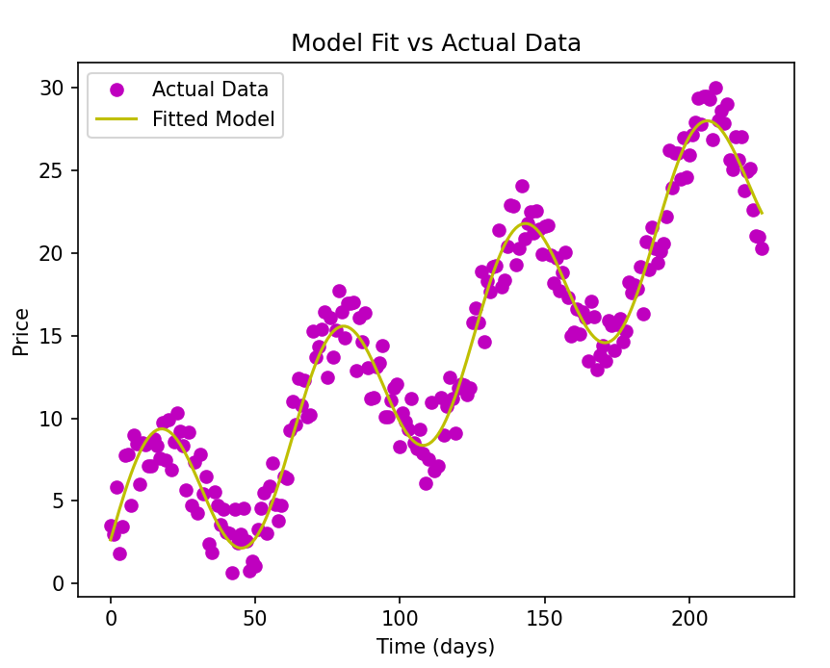

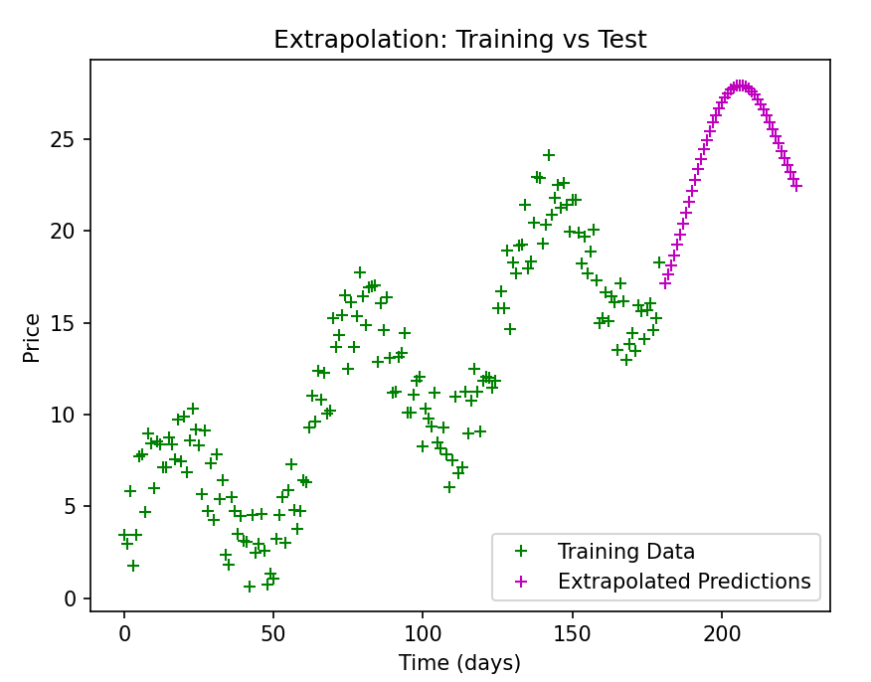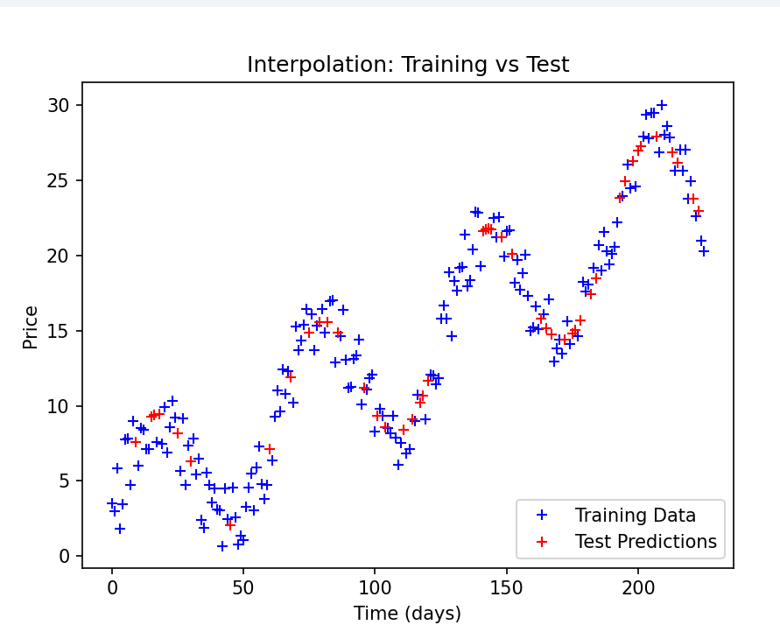

Task 3

We modeled the damped oscillation with the equation ( y = (m_1 + m_2 * x) sin(wx) ). The constants (m_1) and ( m_2 ) can be determined using linear fitting. The frequency (w) is found by testing different values and selecting the one that offers the best fit. After analyzing the coefficients, it’s clear that (f_2) has the greatest impact among the frequencies, leading the equation to simplify to ( y = (m_1 + m_2 * x) sin(x/10) ).

